Mathematics Specialist Unit 3

Test 2: Polynomials and Functions

Student Name: _______________________________________

Time allowed for this task: 55 minutes, in class, under test conditions

Section One – calculator-free section 22 minutes (21 marks)

Section Two – calculator-assumed section 33 minutes (32 marks)

Materials required: Calculator with CAS capability (to be provided by the student)

Standard items: Pens (blue/black preferred), pencils (including coloured), sharpener, correction fluid/tape, eraser, ruler, highlights

Special items: Drawing instruments, templates, and up to three calculators approved for use in WACE examinations.
One page of A4 notes, written on both sides.
Mathematics Specialist formulae sheet.

Marks available: 53 marks

Task weighting: 7%

Section One – calculator-free section
No calculators or notes are to be used.
Access to approved Mathematics Specialist formulae sheet is permitted.
Simplify answers where possible.

Question 1. (4 marks)

If $f\left(x\right)=x^{2}+1$ and $g\left(x\right)=$ $\frac{2}{x}$ find the natural domain and corresponding range for

- fog(x) (2)

- gof(x) (2)

Question 2. (4 marks)

Find an expression for the inverse function of $h$ where $h\left(x\right)=1+$ $\frac{1}{3+x}$ and state the domain and range of $h^{-1}$ .

Question 3. (2 marks)

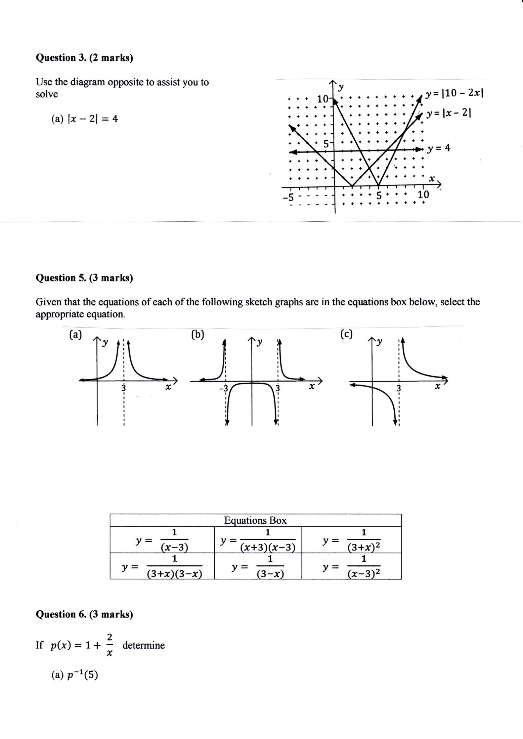
Use the diagram opposite to assist you to solve:

- $\left|x-2\right|=4$

- $\left|10-2x\right|=\left|x-2\right|$

Question 4. (4 marks)

Consider the nature of the graph of $y=$ $\frac{x^{2}-3x-4}{x^{3}-2x^{2}-3x}$ . Describe the effect on the y values of the
graph as

- x tends to $+∞$

- x tends to $3^{+}$

- x tends to $-1^{-}$

- x tends to $4^{-}$

Question 5. (3 marks)

The graph of $y=-2\left|x-4\right|+6$ is shown below. Find $a, b$and $c$ such that the solution to the equation

$-2\left|x-4\right|+6=a\left|x+b\right|+c$ is $4≤x≤6$.

y
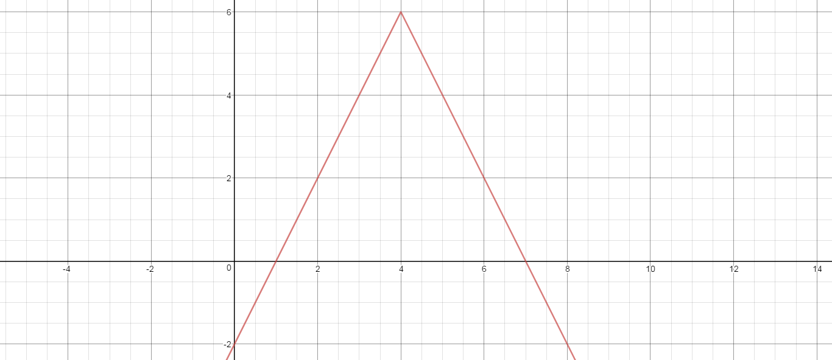

x

Question 6. (4 marks)

If $p\left(x\right)=1+$ $\frac{2}{x}$ determine

- $p^{-1}(5)$ (2)

- The value(s) of x such that $p^{-1}(x)=p(x)$. (2)

End of Section One

This page has intentionally been left blank.

You may use this space to extend your working on a particular question or questions. Remember to number each extension.

Do not turn over the page until so directed.
Section Two – calculator-assumed section
Calculators and 1 page of A4 notes, written on both sides, allowed.
Access to approved Mathematics Specialist formulae sheet is permitted.

Question 7. (4 marks)

The graph of $y=p(x)$ is shown twice below. In diagram (a) show the graph of $y=p(\left|x\right|)$ while in diagram (b) show the graph of$y=\left|p(x)\right|$.

(a) y (b) y
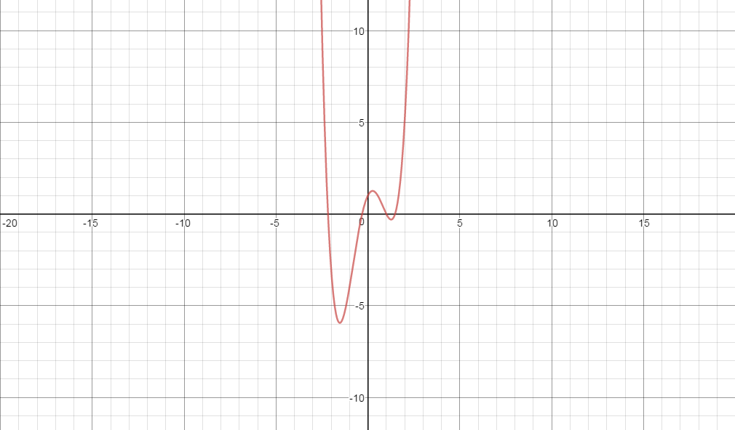


x x

Question 8. (3 marks)

Find an expression for the inverse function of $f(x)$ where $f\left(x\right)=4+$ $\frac{2}{2x-1}$ and state its
domain and range.

Question 9. (4 marks)

Given that $p\left(x\right)=x^{2}-4$ and $q\left(x\right)=$ $\frac{1}{x}$ state the natural domain and the corresponding
range of each of the following functions:

- $poq(x)$ (2)

- $qop(x)$ (2)

Question 10. (6 marks)

Determine all of the asymptotes for each of the following functions:

- T(x) = $\frac{x^{2}+3x}{x-1}$ (2)

- U(x) = $\frac{x^{2}-9}{x(x+3)}$ (2)

- V(x) = $\frac{x^{2}+1}{(2x-1)(x+2)}$ (2)

Question 11. (4 marks)

Consider the graph of $y=$ $\frac{x^{2}+x-2}{x^{3}-2x^{2}-x+2}$ .

- Locate any asymptotes. (2)

- Describe any other discontinuities. (2)

Question 12. (5 marks)
The graph of $y=f(x)$ is shown below. It has asymptotes at $x=2, x=6, y=-\frac{1}{2}$ . On the same set of axes draw the graph of $y=$ $\frac{1}{f(x)}$ , clearly showing any roots and asymptotes.

y
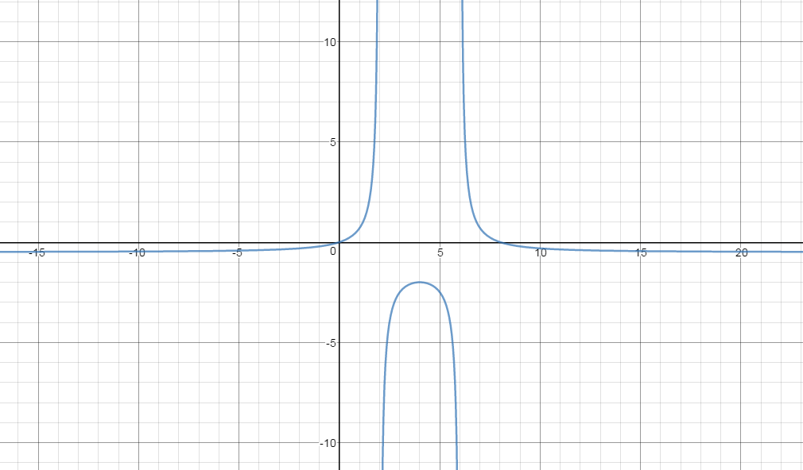

x

Question 13. (6 marks)

The graph of $g\left(x\right)=$ $\frac{(x-4)(x-1)}{x-2}$ , $x<2$ is shown below:

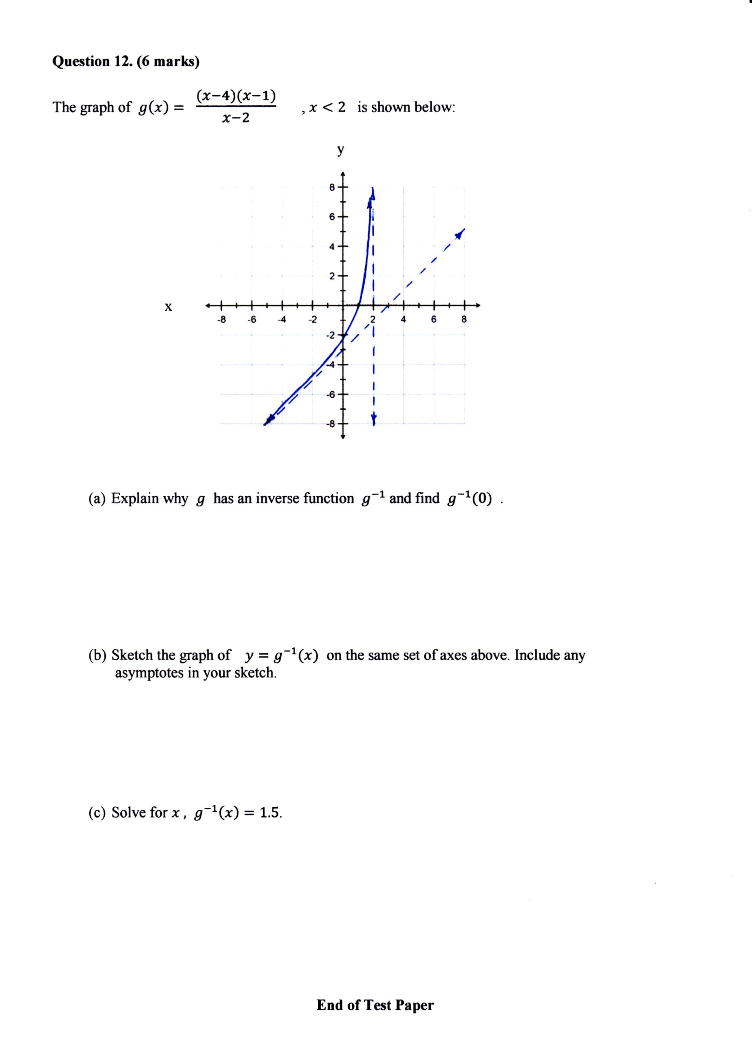

- Explain why $g$ has an inverse function $g^{-1}$ and find $g^{-1}(0)$ . (2)

- Sketch the graph of $y=g^{-1}(x)$ on the same set of axes above. Include any
asymptotes in your sketch. (2)

- Solve for $x ,$ $g^{-1}\left(x\right)=1.5$. (2)

End of Test Paper
This page has intentionally been left blank.

You may use this space to extend your working on a particular question or questions. Remember to number each extension.

